QUESTION 1 SUMMERY

**Corporate finance:**

* Profitability:
  + OP. Surplus (OPS): Profit, Net.
  + Net Cash Flow (NCF): if –ve, can be sustained in the short run, if we have CASH (BANK), but must be turned into +ve in the Long run to pay off debt
* Using OPS to measure profit:
  + ROTA = OP. Surplus / TA
  + ROE = OP. Surplus / Equity
  + COC = Long term Loan interest / Long term Debt
  + ROTA, ROE, must be more than COC to be good
* Gearing:
  + *******Gearing = Long term Debt / Equity
  + Gearing to TA = Long term Debt / TA
  + Show us the Co. ability to take more loans in the future, if it reached the point where Loans = Equity, this option is no more.
* CASH (BANK)
* Corporate HQ = Corporate HQ overhead / Total overhead
  + The ratio show us whether it adds value through parenting advantage (lower is better)
* Interest as % of OPS= interest / OPS

**Product Level:**

|  |  |  |
| --- | --- | --- |
| Product | Finance | |
| Product A | Product B |
| M.S | From table M.S % | From table M.S % |
| T.M | Orders / M.S% | Orders / M.S% |
| Labor attrition | From table | From table |
| R.O.S% | Gross Profit/Sales Revenue | Gross Profit/Sales Revenue |
| Dev % of Sales | Product Dev./ Sales Revenue | Product Dev./ Sales Revenue |
| Mrk % of Sales | Product Mrk./ Sales Revenue | Product Mrk./ Sales Revenue |

**PLC:**

* If a Product is in maturity, Mrk% and Dev% expenditure should be low,
  + If it is in Growth it should be high.
* If a Product is in maturity, inventories should be low, And JIT Delivery.
  + If it is in Growth it should be high, compare to Demand of Next Year.
* If a Product is in maturity, price should be closed to competing price.
* If a Product is in maturity, attrition should be low due to experience effect.

**Expansion Matrix:**

Decide whether the product is related diversification or unrelated diversification, (New Product, New Market).

**Portfolio Modeling (BCG):**

Mrk Share, Growth to decide (Cash Cow, Star,?, or DOG), and how it is managed like, depending on whether wrong action are taken from the firm, And decide strategy accordingly (Defender, Prospector, analyzer).

**Five Forces:**

|  |  |  |
| --- | --- | --- |
| Market Force | Product A Mature | Product B Growth |
| Threat of new Entrant | Low | High |
| Threat of Substitute | High | Low |
| Rivalry | Low | High |
| Bargaining power of Buyer | Low | High |
| Bargaining power of Supp | Low | High |

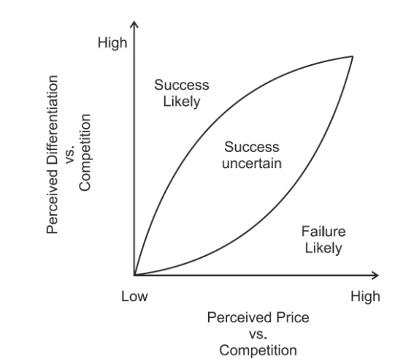It could differ depending on the question; to decide how much is the competitive forces in the industry for each product.

**Price and Differentiation:**

* Success Likely
* **Success Uncertain**
* Failure Likely

State where the product is likely to be now and where it is heading, and compare with Competing Price.

**Value Chain**

**Try to find the weakness in the matrix**

Supporting Activities:

* **Firm Infrastructure**
* **Procurement:** inventories, and High costs of products
* **HR management**: Conclude from attrition rate
* **Technology**: use of Tech to Differentiate the Product
* **Linkage**: linkage btw product and Competitive advantage

Primary Activities:

* **Inbound logistics:** managing products according to BCG matrix
* **Operations**
* **Outbound Logistics:** Talk about Distribution Channels
* **Marketing and Sales**: from Mrk% to decide if it is sufficient
* **Services:**

**Synergy**

Knowledge based, labor, resources, Tech based, to capitalize Co. core competences.

**Sensitivity Analysis (Optional)**

Talk about possible Scenarios

**Competence (Conclusion)**

Determine the diversification, the Competence of the Co., Compt ad & do you support it.

**SWOT Analysis**

|  |  |
| --- | --- |
| Strengths  Ability to take further loans  Co. reputation and Brand Loyalty  Market Share  Low Cost/ Differentiation  +ve Cash Flow  ROE & ROTA above COC  Star or cash cow products  Customer Base | Opportunities  Developing ? to Start  Maintain Cash cow  1st mover advantage  Differentiate product  Regain Market share |
| Weaknesses  High gearing  -ve NCF/ Liquidity Problem  Low return on Sales  Weakness in the Value Chain  Low GM  Losing Market Share  No clear Competitive advantage | Threats  Increased Competition  Substitute  Losing Market share  PLC (in Decline)  Bank concerns on gearing ratio  Losing Differentiation  New entrant (low entry barriers) |

+ Sensitivity Analysis (scenarios)

Comment on whether

* Strengths are aligned with Opportunities or Threats.
* Weaknesses are aligned with Opportunities or Threats.

Question 2:

Process Model

**Who decides What to do**

* **Strategist:**

Mr. Strategist is analyser he understood / did not understand the business he is in, Principle agent Problem, he had experience for…, power Culture or Team Work, Analyzer, Prospector, defender.

* **Objectives:**

Fixing the Business, restructure, increase profit, improve value chain, expansion (Organic, or Acquisition), to compete in (quality or price), SMART.

* **Over All Who decides What to do:**

Mr. Strategist and his vision, problems he resolved, where did he focus, Principle agent problem.

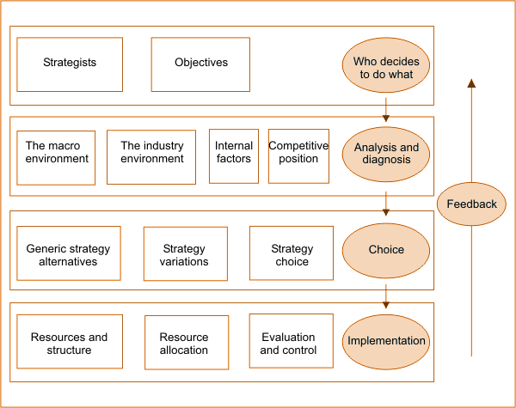

**Analysis and Diagnoses**

* **The Macro Environment: (PESTED)**

**Political**: union resistance, regulations.

**Economical**: Economic Barriers.

**Socio-cultural**: Traditions & life styles.

**Technological**: Tech. Challenges, & adoption.

**How did the Strategist deal with the Macro Trends, effectively scanned or not,**

* **Industry Environment:**
  + **Market Structure**: General info about the industry, oligopoly, monopoly, market homogeneous or heterogeneous.
  + **Five Forces**:

|  |  |  |
| --- | --- | --- |
| Competitive Force | reason | effect |
| Threat of new Entrant |  | High |
| Threat of Substitute | Tech. effect to substitute | Low |
| Rivalry | Oligopoly, competitiveness | High |
| Bargaining power of Buyer | Availability of different choices | High |
| Bargaining power of Supp | Cost of switching | High |

The Profile suggest highly competitive/ or not so much industry, which makes it difficult to generate GM's, and how to try to reduce its competitiveness.

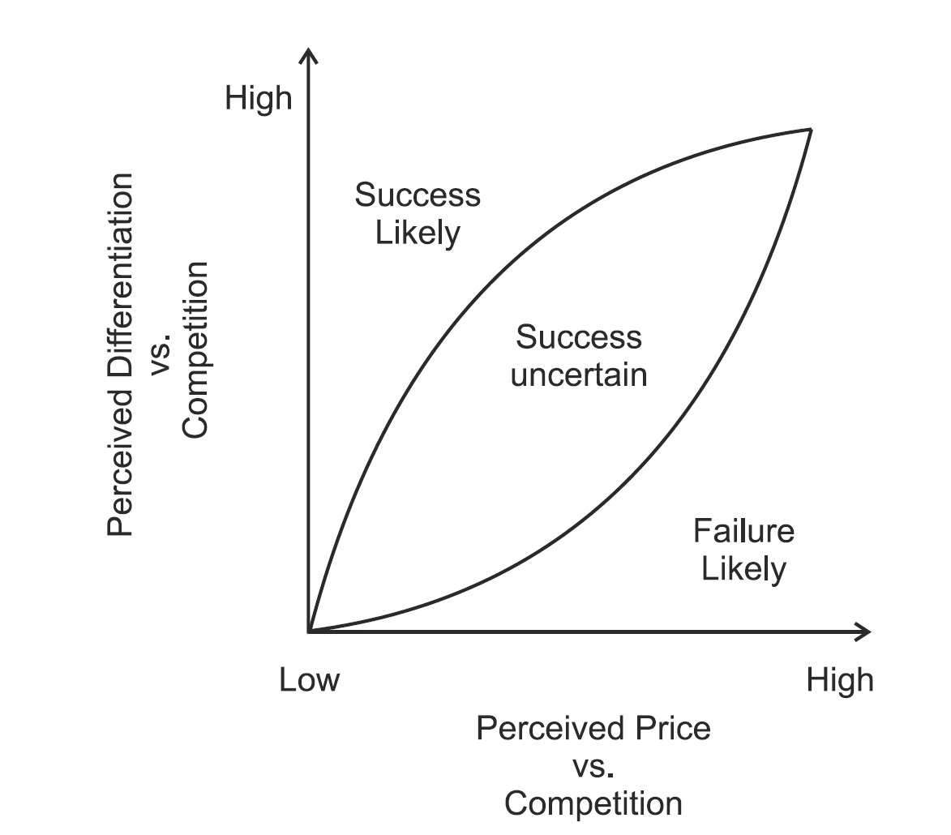

* + **Price Differentiation**: where it is located now and where is it heading in the Price**-**Differentiation curve. (up/down)
  + **Product Life Cycle**: talk about the product, growth, maturity, or decline, and what Mr. Strategist did in those conditions.
  + **BCG Matrix**: Dog, Star, ?, and Cash Cow, and how the Co. shifted between those locations with time. (where is it heading)
* **Internal Analysis:**
  + Org. Culture: if any changes in the culture.
  + Value Chain: Porter version, how did the strategist enhance and improve the Value chain.
    - Primary activity
      * inbound logistics: Supplier relations, vertical integration
      * Operations: Production efficiency
      * outbound logistics: vertical integr., & Distribution channels
      * Marketing and sales: consumer knowledge/ attractiveness
    - Supportive activity
      * Management systems: Empowerment (SDT), Collaboration
      * Technology: lvl of innovation
      * HR management: Recruitment, training.
      * procurement: supply chains

**the Strategist must focus on the weak links in the value chain & linkage Btw dept.**

* + Core Competence: what generates the competitive advantage to the Co., what the Co. Does BEST ! -cannot be imitated-
* **Competitive Position:** low cost, differentiation, focus, mass production, global, whatever gives the company a Competitive advantage.
* **Overall Analysis and Diagnoses:** comment on the total environmental and internal factors analysis, where improvements happened

**Choice**

* **Generic Strategy (Choice):**
  + Corporate Level: Corporate strategies like Stability, Expansion, Retrenchment, or a combination of them
  + Business Level: Cost leadership, differentiation, focus, stuck in the middle.
  + Decision Maker strategy: Prospector, analyser, defender, reactor.
* **Strategy variation:** what changes did the Strategist make in the Co., expansion, growth, related or unrelated diversification options, plus regarding the BU lvl whether we moved from Stuck in the middle to cost leadership or whatever.
* **Overall Choice:** Proactive Vs. Reactive, strategist's actions (Changes) within the Co. tradeoffs paradox., whether Mr. Strategist dictated the Choice (power Culture) or included others in the decision making (Consultation)

**Implementation**

* **Resource and Structure:** Change in org. structure (centralized or decentralized), delayering,
* **Resource Allocation:** how the strategist was able to allocate the resources in the Org. efficiently or not, investing to add value in relation with elements of value chain.

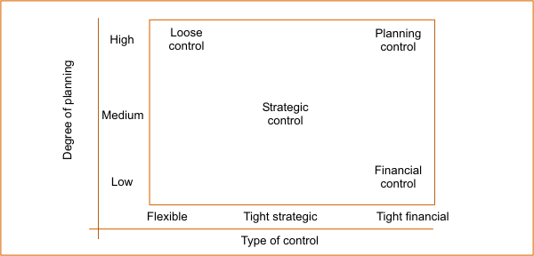

* **Evaluation and Control:** state in which area is your Co. in the Evaluation and Control Matrix
* **Overall Implementation:** putting Strategic Choice into action effectively.

**Feedback:** Mention whether or not it is a learning organization (based on pool of knowledge /adaptability ,effective communication and org. restructure that reduces time needed to forecast the market)

**Overall Strategy:** mention whether the Strategic process is robust or not, and where was the deficiencies in his model, or achievement of strategist and if Concerned with (internal affairs/financial control/expansion and growth /or no clear cut)